HARDWARE SETUP
To install the hardware and make it ready for firmware upload, following steps are required:
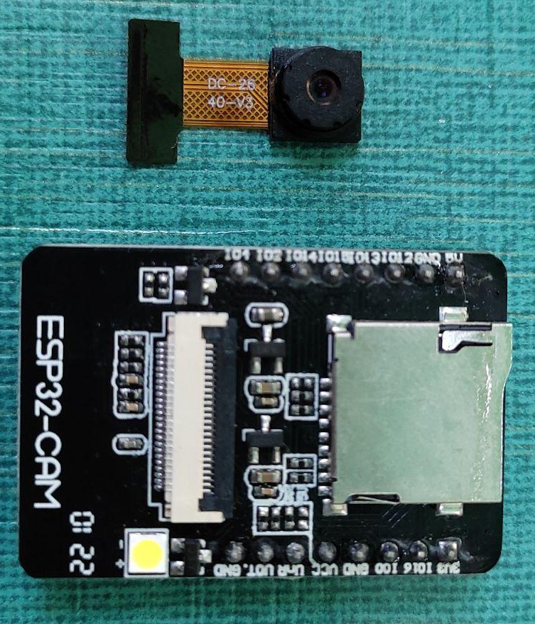
- Firstly, connect the Camera Sensor with the FPC connector of ESP32-CAM , as shown:
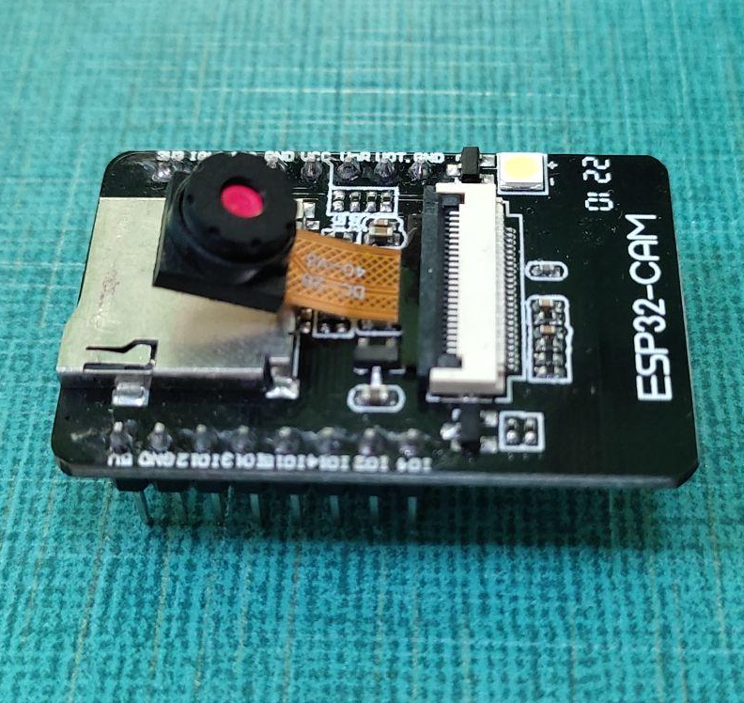
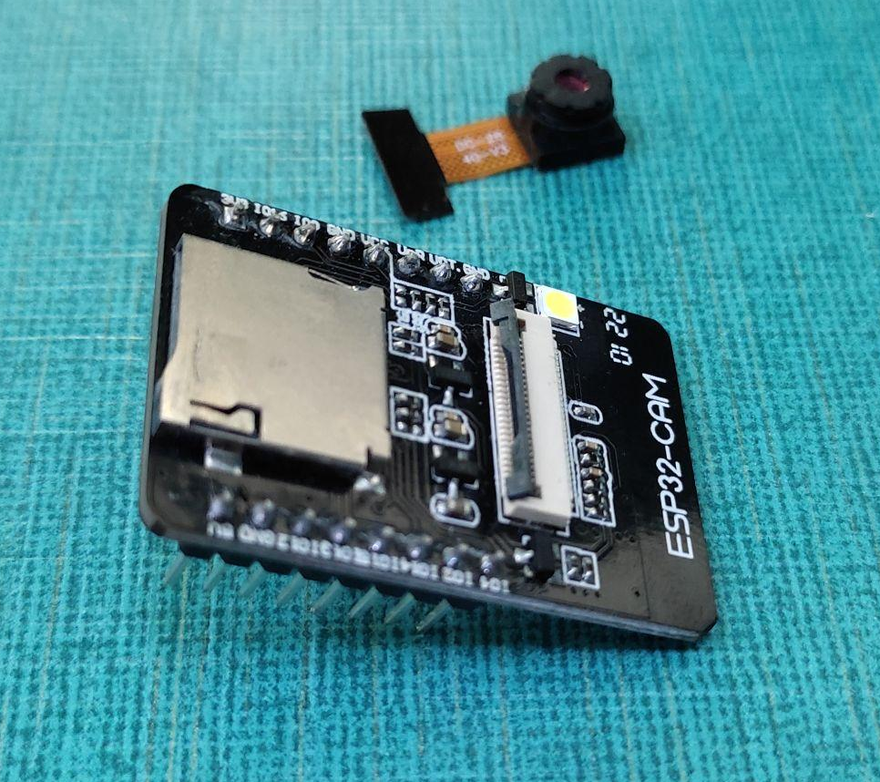
- Connect ESP32 - CAM with USB-to-TTL converter by using female-to-female jumper wires, as shown:
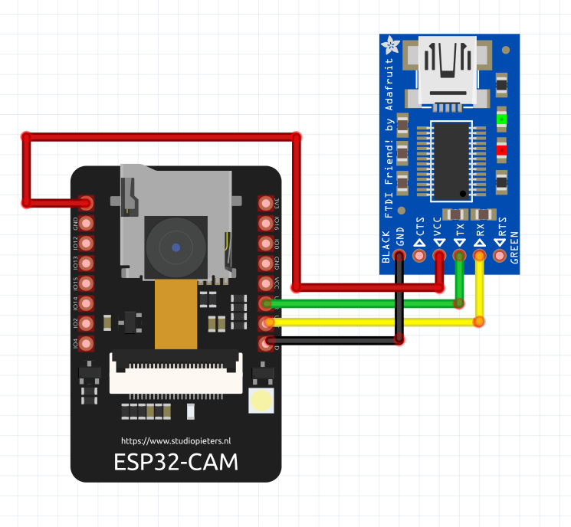
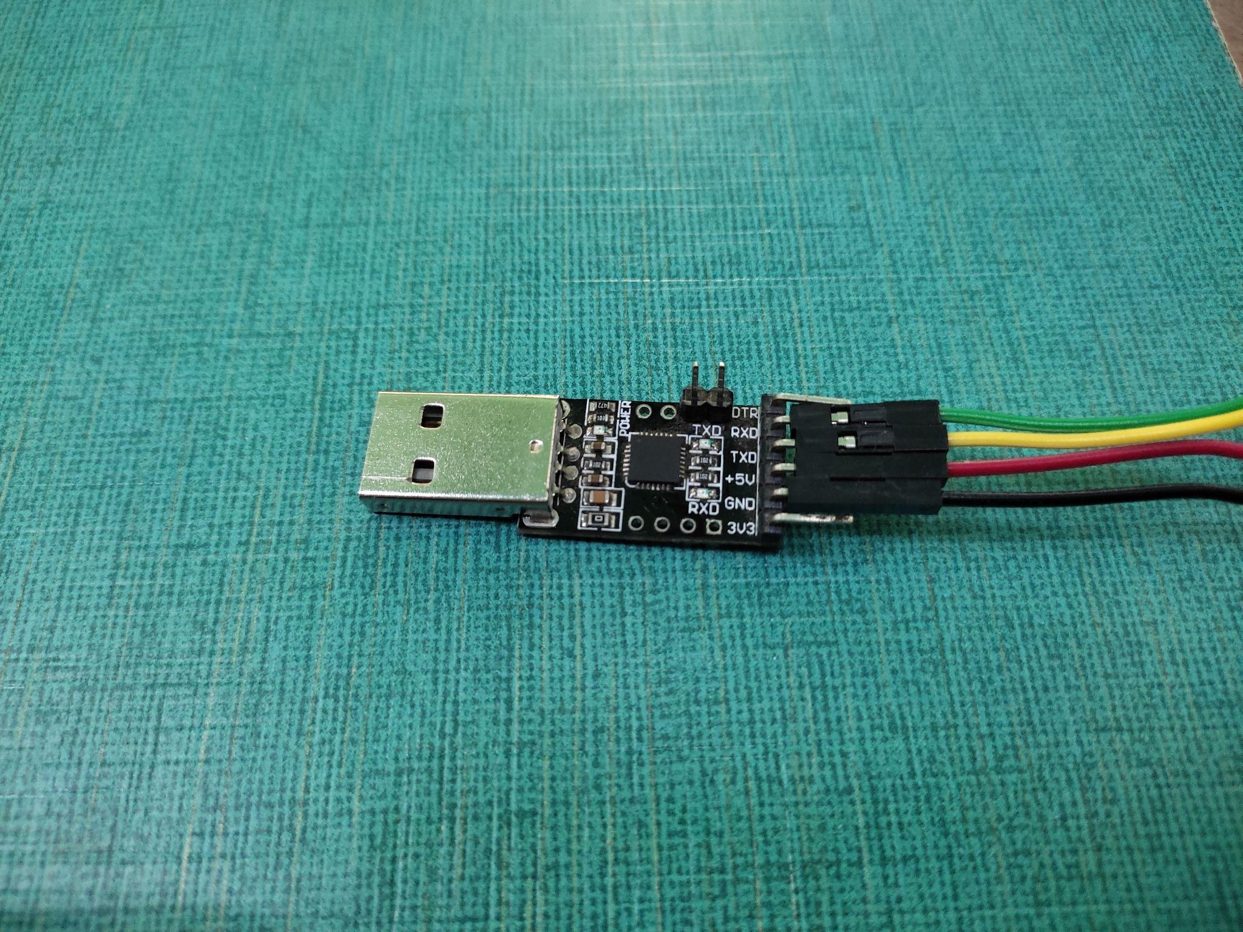
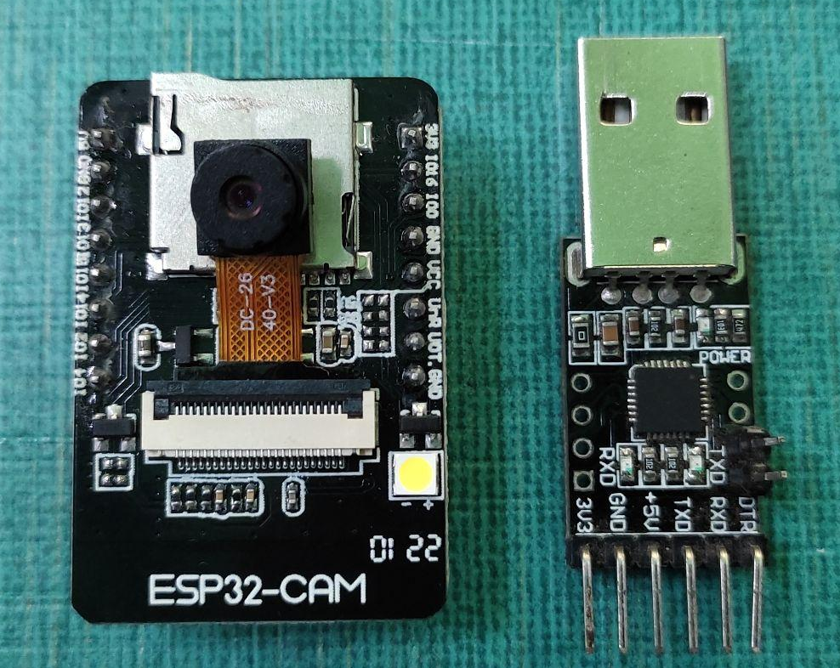

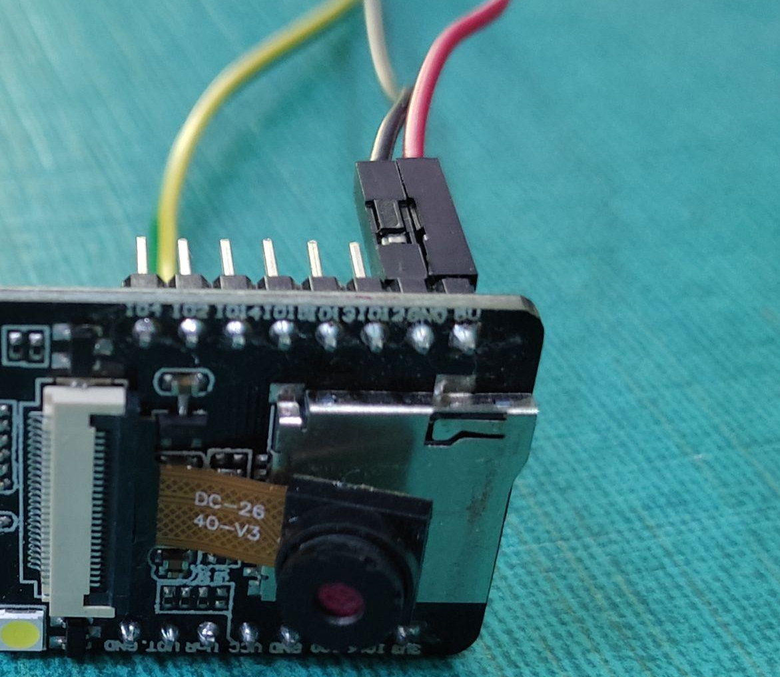
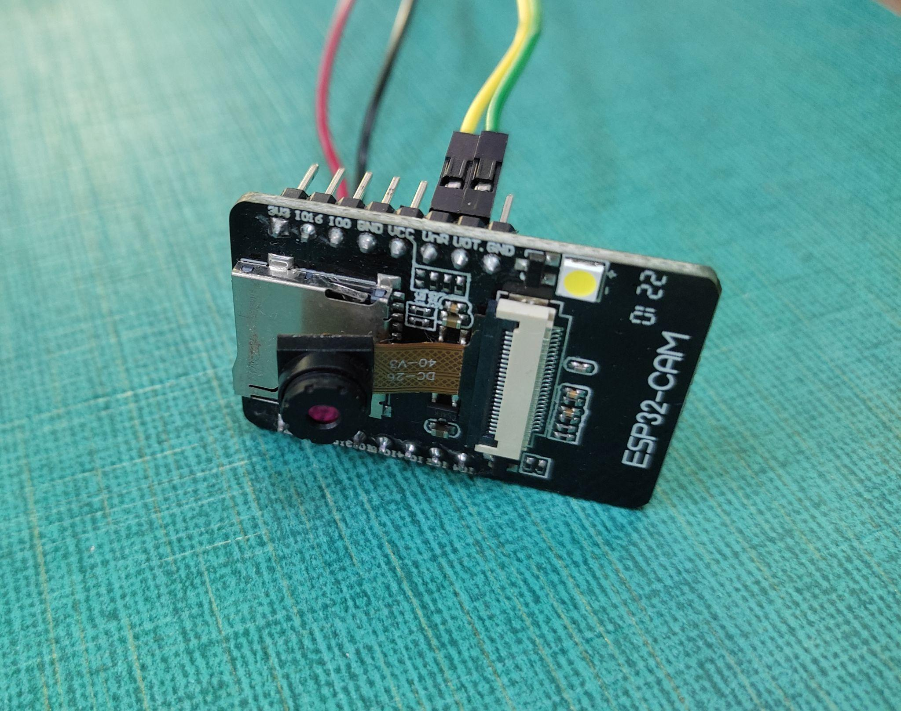

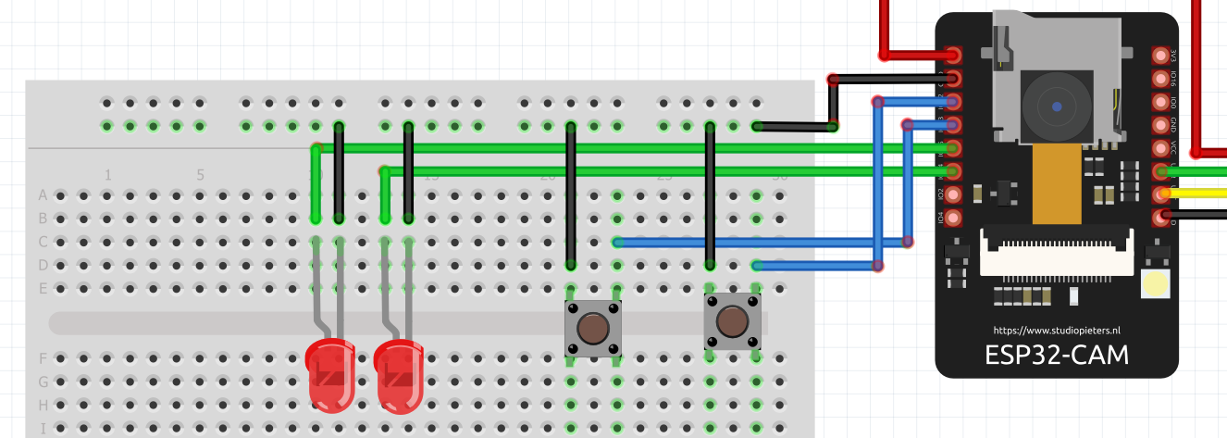
- Connect Leds and Push Buttons with the above circuit, by using breadboard and jumper-wires.
- Finally, connect the USB-to-TTL converter with your PC.

SOFTWARE SETUP

- Install ESP-IDF in Windows
- Setting Up Firebase

ESP-IDF Installation in Windows:
Opens the official ESP32 ‘getting started’ webpage by Espressif. Scroll down until you reach the Manual Installation section. Here click ‘Windows Installer.’

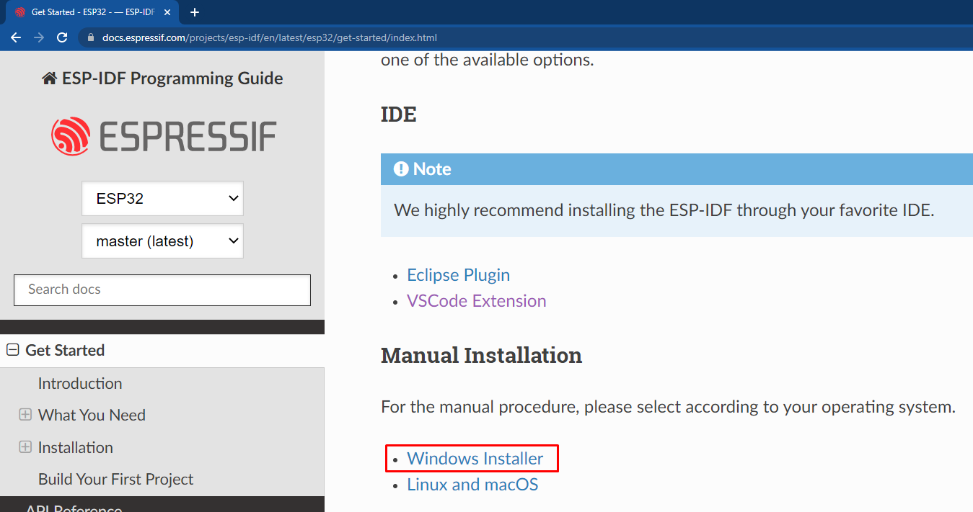

You’ll redirect to a new page and now click on “Windows Installer Download”. After that select the “Universal Online Installer”.
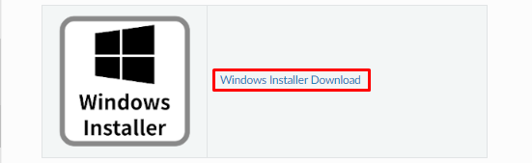
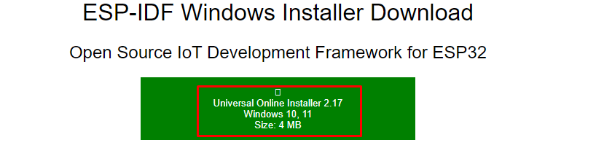
Now, open the downloaded .exe file, and begin esp-idf installation.
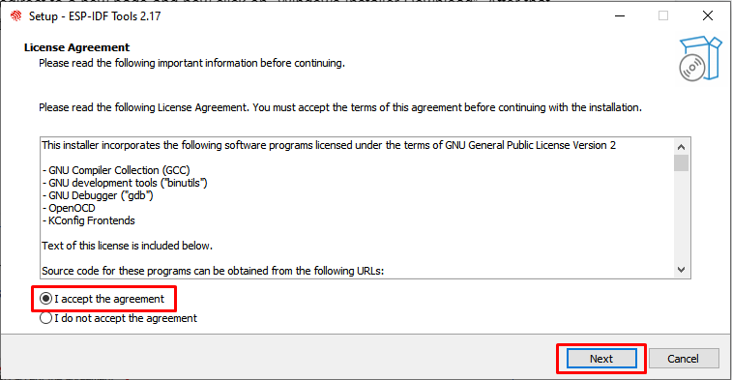
Select “Download ESP-IDF” and click “Next”.
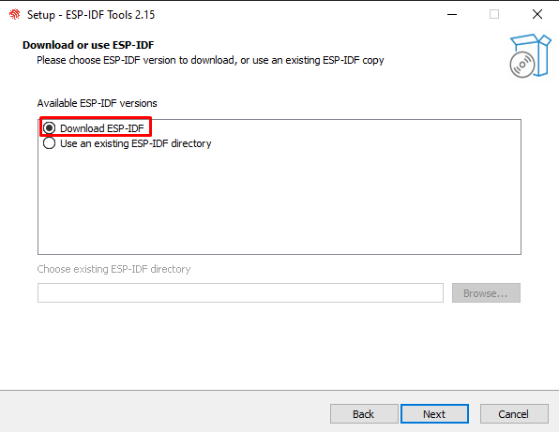

Select the “V4.4.3(release version)”.
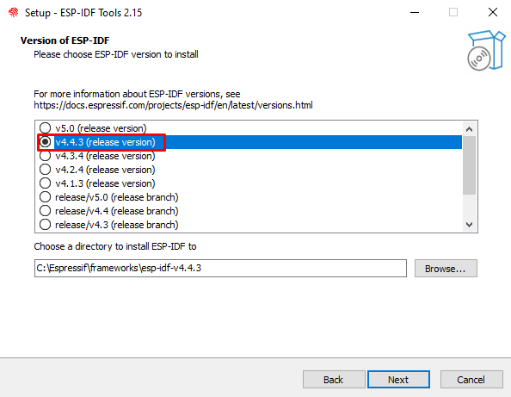
In the “Select Components” tab, remain it as it is and click “Next”. Now the installation begins. Click the Finish button to exit the setup.
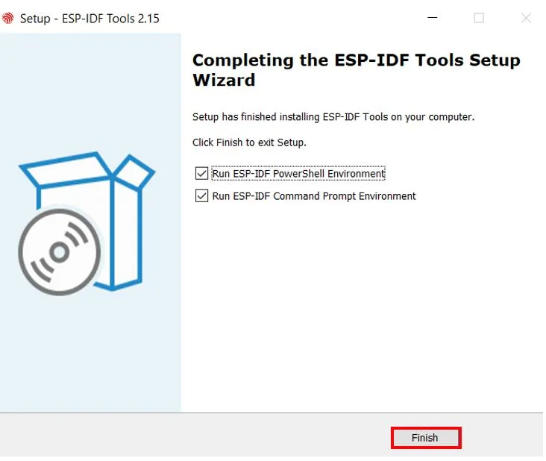

FireBase Setup:

Now, setup the firebase by following these steps;
Open the official Firebase website and click on “Get Started”.
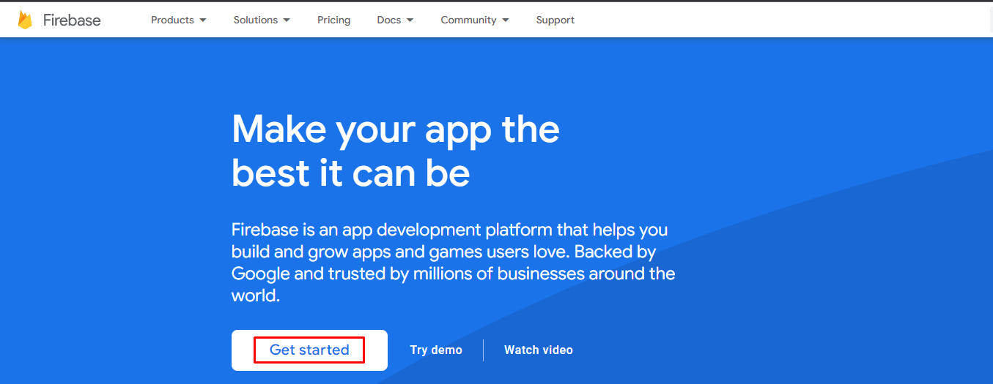

Sign-in with the provided credentials, and the “Firebase Projects” page will open. Now click on “MatKenn-ERPSystem”.
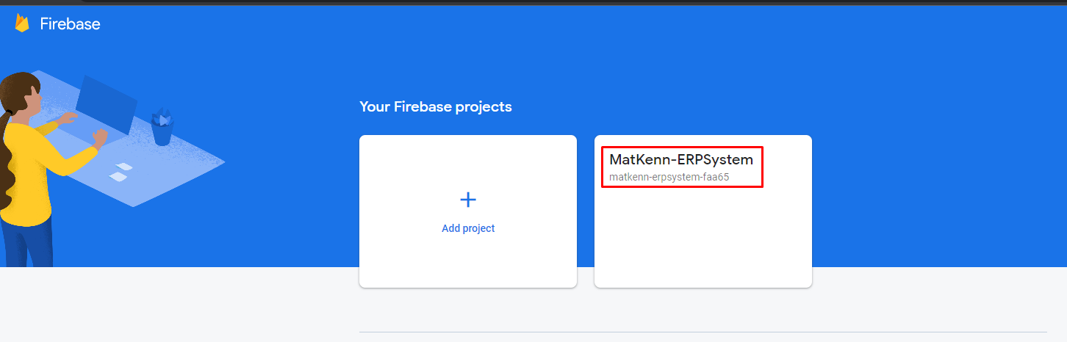

Go to Realtime Database->Data, and here you can access the qr-scanner data.
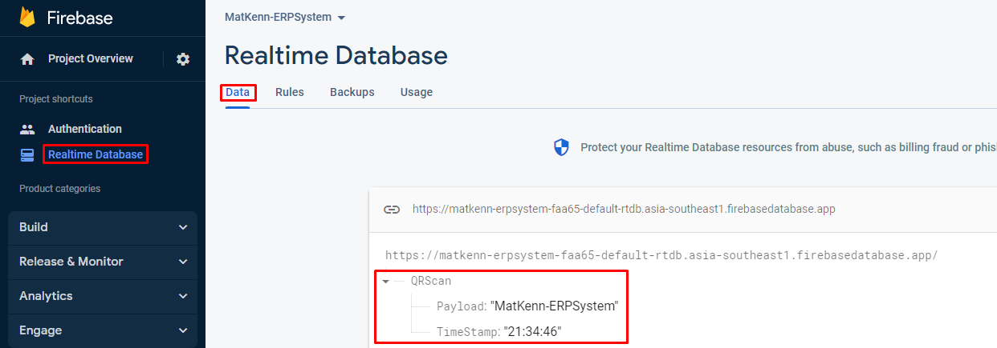

BUILDING, FLASHING & MONITORING (FIRMWARE):

- Project Build:
Open “ESP-IDF CMD” from the Windows start button.

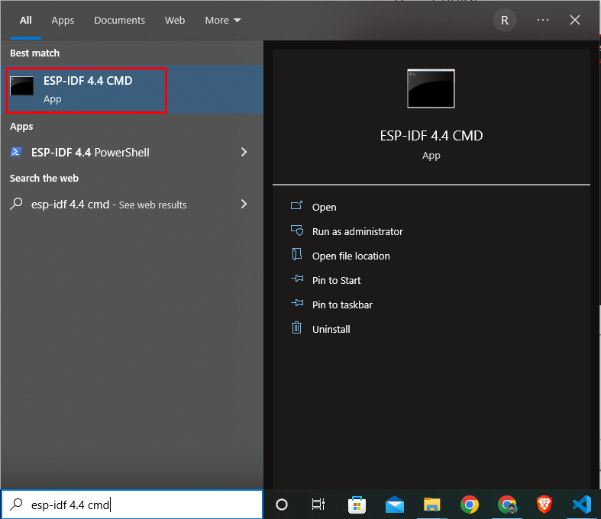

Now copy the project directory and open it in the ESP-IDF CMD;
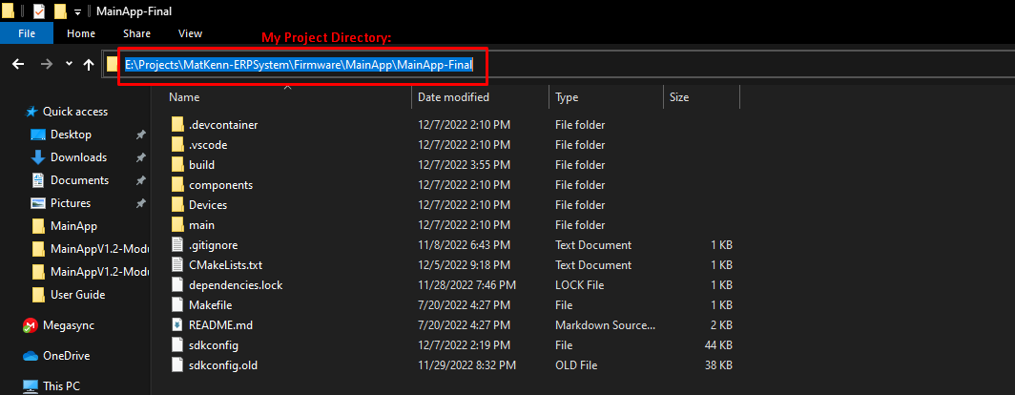
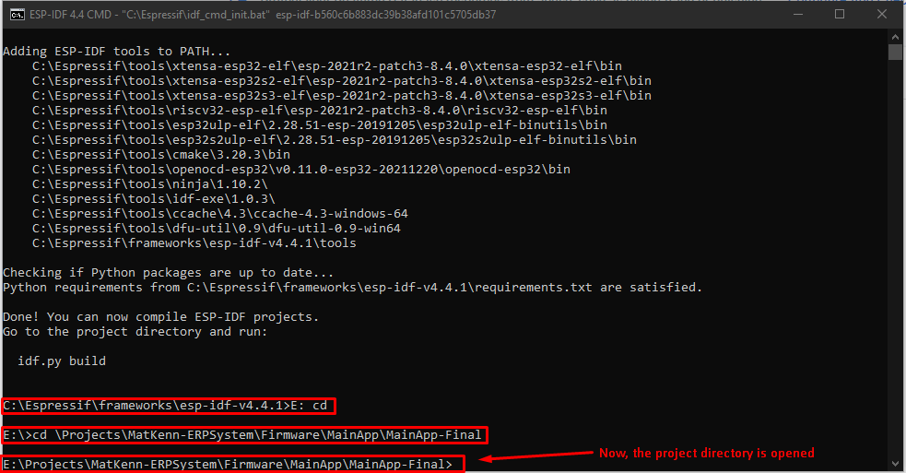

Open the “menuconfig” running the command; idf.py menuconfig
Change the following parameters & click save.
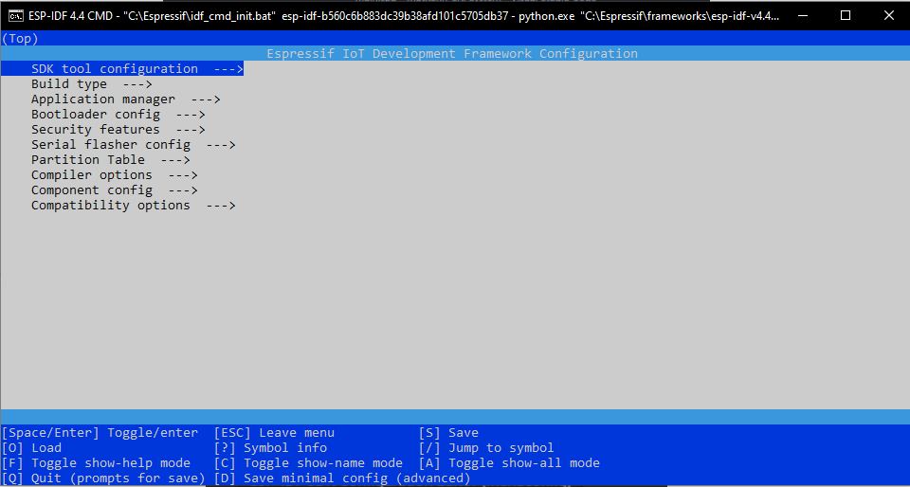

Go to the Partition Table and select “Single factory app (large), no OTA”.
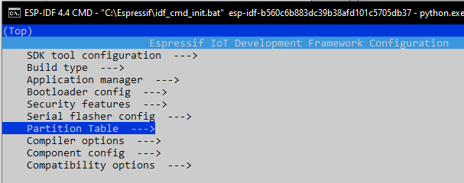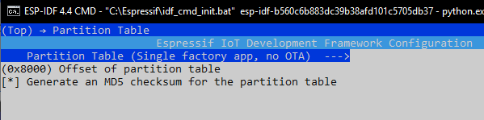
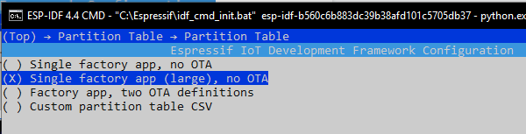

Go to the “Compiler Options” and select the “Enable C++ exceptions”.
Set “Emergency Pool Size” to 0.
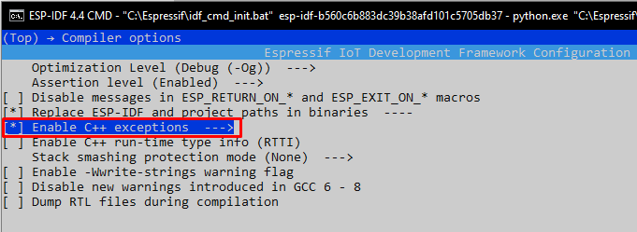
Press “S” and “Enter” to save the configuration.
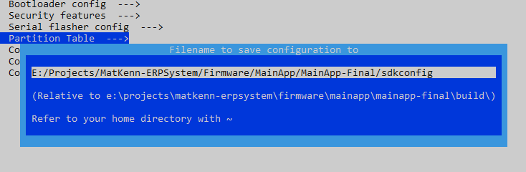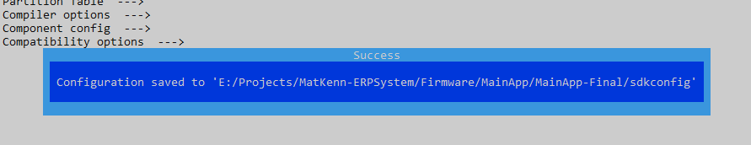

Press “ESC” to exit menuconfig.

Now, run the following command in the esp-idf terminal, and Build the Project.
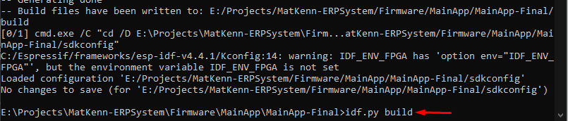
The project build is complete and ready to flash.
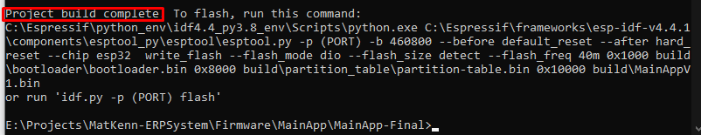

- Flashing:
First you have to connect the GPIO0 to GND and press the reset button of the ESP32-Cam board.
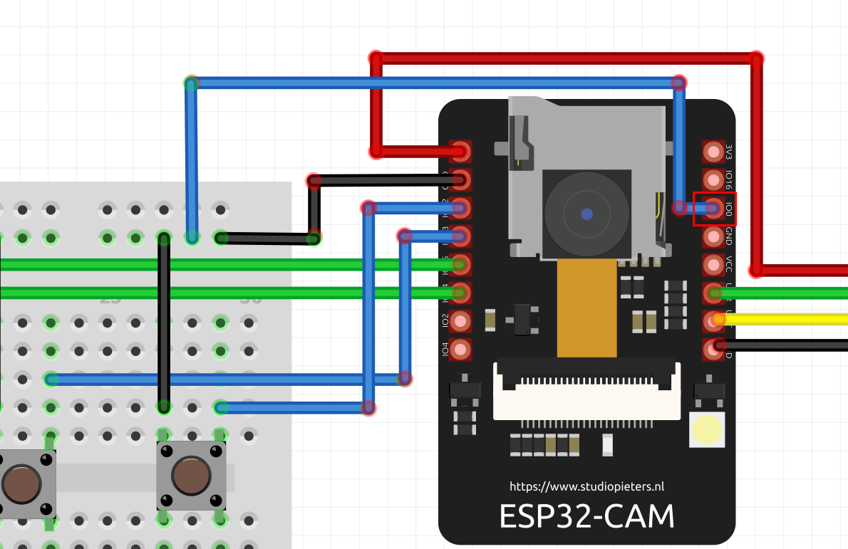

Goto Device Manager->Ports and check the COM Port.
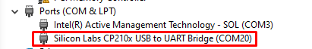

Now, run this command on the esp-idf terminal, “ idf.py -p COM20 flash monitor”
Flashing is done. Remove “GPIO0” from “GND” and press the reset Button of the board.
